**British Airways Customer Review Analysis**

**Introduction:**

In this project, I explored a dataset pertaining to the airline company British Airways and the reviews customers left about their flights. There were two main categories of variables to explore in this dataset – contextual and metric variables. Some of the contextual variables I used in the analysis include aircraft type, date of review, country of flight, traveler type, and seat type. The metric variables are Key Performance Indicators, KPIs, pertaining to ratings customers gave based on flight satisfaction in different areas. These areas are: overall rating, cabin staff service, entertainment, food & beverages, ground service, seat comfort, and value for money. These KPI metrics are what I decided to focus my analysis on, as they give direct insight into customer preferences about British Airways.

After establishing what the dataset contained, I decided to establish a few broad baseline questions to guide my analysis as I create the dashboard:

1. What trends, if any, can be observed in customer satisfaction metrics over time?
2. How do customer satisfaction metrics vary across different aircraft types?
3. Which countries are most frequently represented in the reviews, and where are the highest ratings concentrated?

**Setup:**

In order to begin the analysis, I first needed to build a few different parameters and calculated fields inside Tableau, in order to filter the data. An example of a parameter I built was called Pick a Metric, which allowed the user to specify which metric they would like to look at. Building off of this parameter, I built a calculated field called Metric Selected that detects whichever metric the user selected and displays the average of that. Lastly, some other filters I included here were Date Range, Traveler Type, Seat Type, Continent, and Aircraft Type. It should be noted that one of the Aircraft Type categories, titled Various, includes all aircraft that had less than 10 reviews.

**Findings:**

In this section, Exploratory Data Analysis is performed in order to investigate the questions and generate key insights.

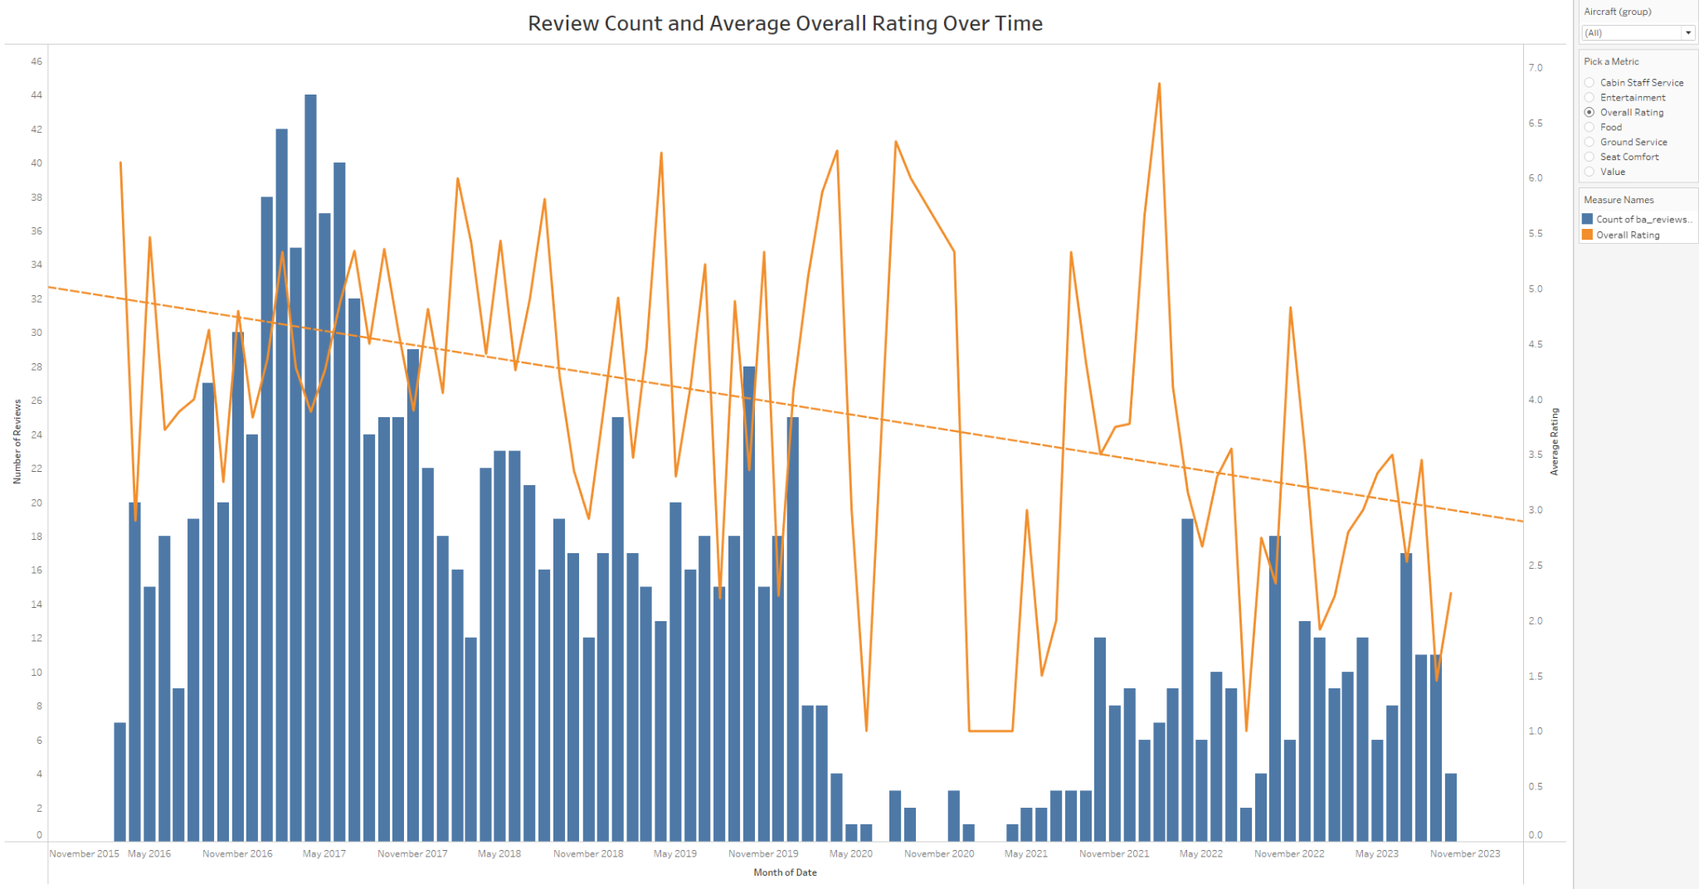

One of the first findings made is that, for a few months following May of 2020, there was a large drop in the average rating for most metrics. By examining the number of reviews, which are the blue bars on the figure above, we can see that this is a result of few reviews being submitted by customers during this time frame. This can be attributed to Covid lockdowns, as many new regulations came into effect that prevented people from flying. In addition, we can also see from the trend line that Overall Rating has been dropping since 2016, potentially indicating a decline in the service British Airways is offering. This stagnation and decline is further demonstrated by the 2 figures about KPIs below.

*March 2016 - January 2020:*



*July 2020 - October 2023:*



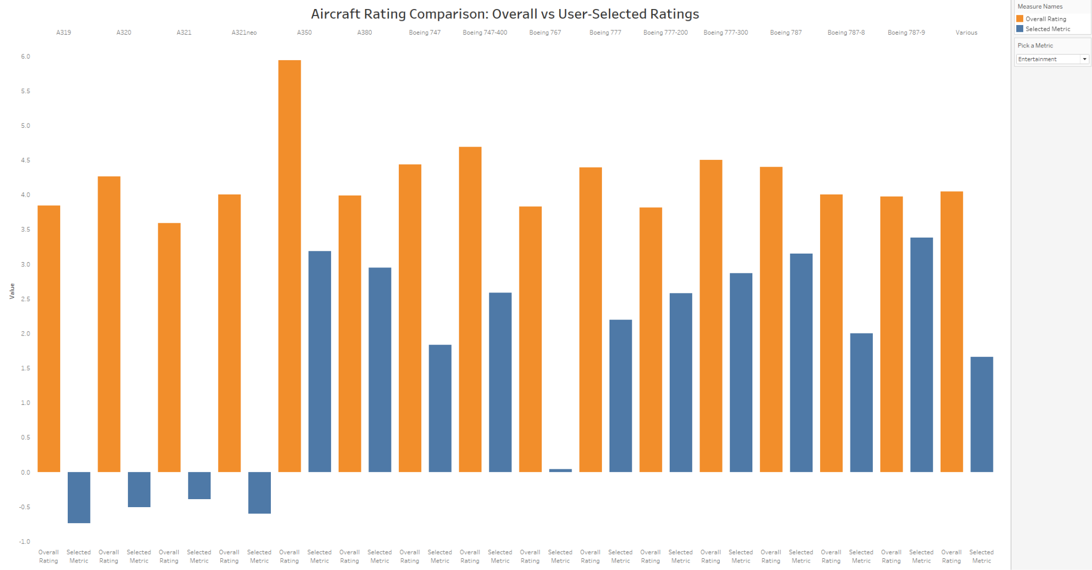

The next finding was discovered regarding how individual metrics compared to the Overall Rating by aircraft. In the figure above, the orange bars represent the average Overall Rating by aircraft and the blue bars represent the average rating of the user selected metric, Entertainment in this case. When comparing the user selected metrics, most of them were somewhat similar to the overall rating. However, when selecting the Entertainment metric, we can see that, aside from all aircraft having a lower score compared to Overall Rating, the aircraft A319, A320, A321, A321neo, and the Boeing 767 were all outliers in how low their scores were.

Given these results, I also decided to investigate the rating for Food, considering its similarity in how it directly impacts the enjoyment of a person’s flight. The results of this are shown in the figure below. We can see that, although not as drastic compared to entertainment rating, there is a very similar decline in food rating, across all aircraft. Together, these two charts seem to demonstrate that the biggest detriment to the overall rating is lack of customer flight enjoyment.

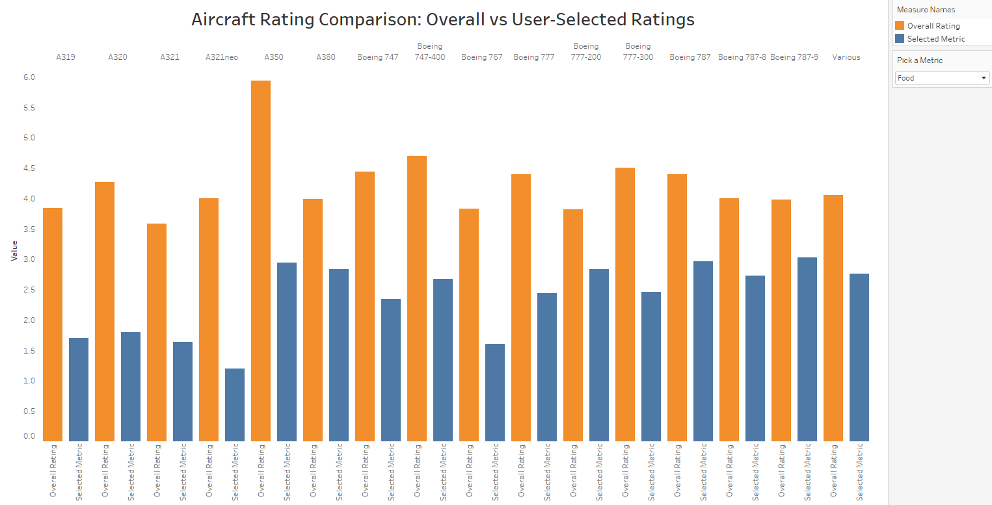

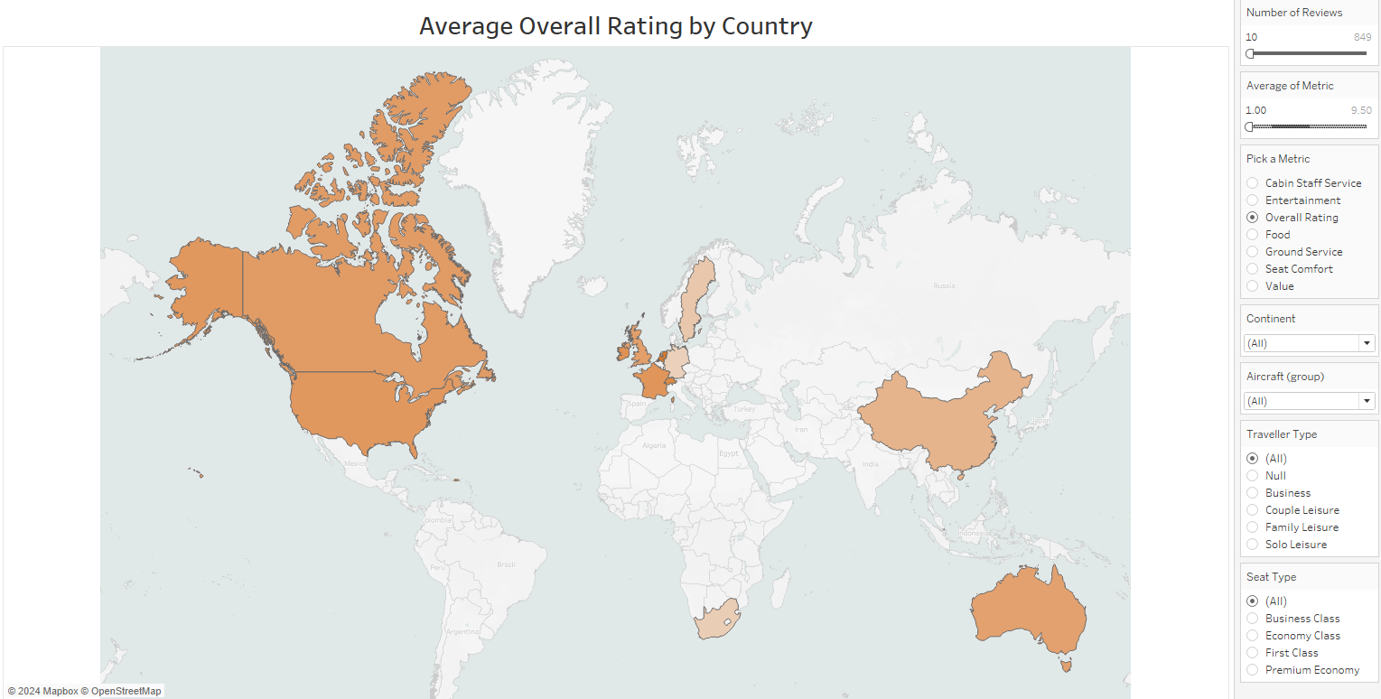

The final finding was discovered when investigating the third question. As I was examining the map, I noticed that there were many nations with only 1 review, which isn’t a large enough sample size to give a truly representative rating. For example, service in Turkey seemed overwhelmingly positive, as it had an overall rating of 8, but upon closer inspection there was only 1 review for the entire country. Therefore, I decided to filter the nations by having at least 10 reviews or more.

From there I was able to identify the Netherlands as having the highest score, with an average Overall Rating of 5.18. That being said, there were many other nations with a high score as well, with the United States, Canada, France, Switzerland, Australia, Ireland, and the UK all having an Overall Rating over 4. However, something this map also showed is that some European countries were less pleased, with Sweden having a score of 3.31, Germany having a score of 3.1, and Belgium having a score of 2.4.

Given that the previous finding exposed low Entertainment scores and low Food scores, I decided to try filtering the map by these metrics, instead of Overall Rating. The topmost of the figures below reflects the updated map filtered by Entertainment, while the bottommost figure reflects the changes when filtered by Food.

Immediately we can see that the European market is greatly dissatisfied with the level of entertainment provided on flights. Sweden’s score drops to 0.62, Germany’s is 1.07, and Belgium’s is 1.7. Interestingly, this trend extends to other European nations as well, even those who previously had a higher overall rating. Ireland’s score drops to 1.82, the UK drops to 1.27, Switzerland drops to 1.8, France drops to 0.45, and even the Netherlands drops to 1.45, despite being the Overall Rating leader.

Although this plummet in rating seems most prevalent in the European market, even the North American market dropped off, with Canada having a score of 2.53, and the United States having a score of 2.27. This pattern is only reaffirmed when looking at the map filtered by Food, with most nations having nearly identical Food scores if compared to Entertainment. Interestingly, China seems to be an outlier, as their Food score was 3.75, much higher than the 1.83 they scored for Entertainment.

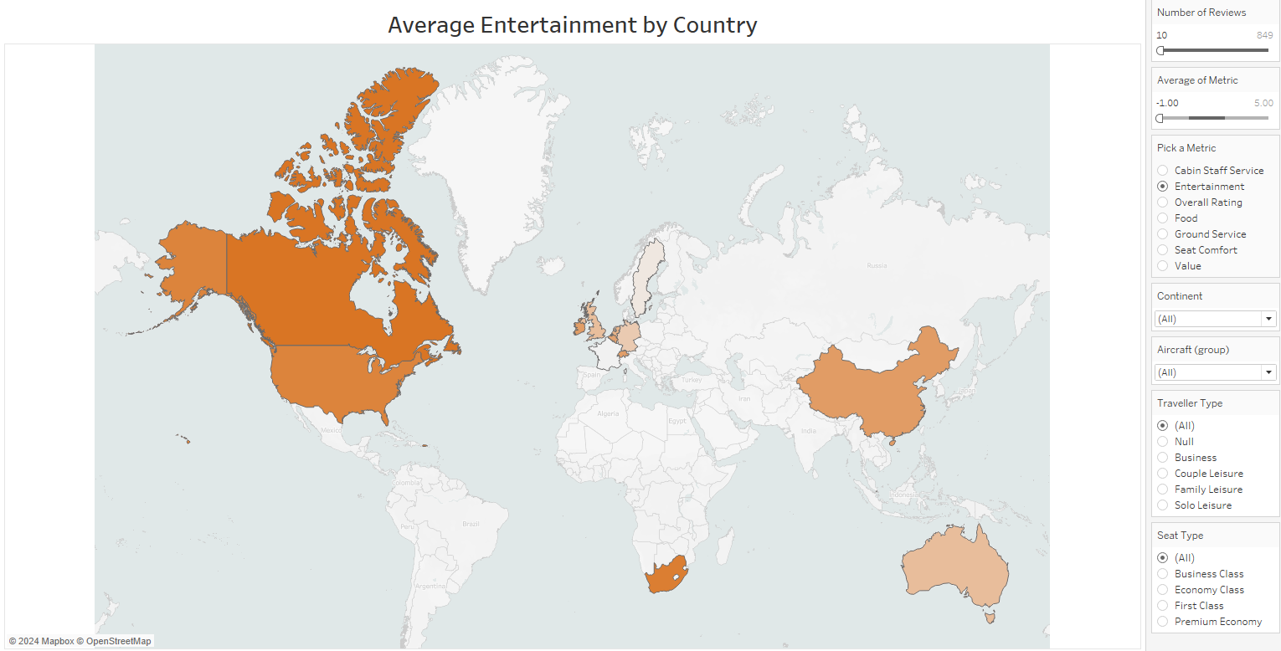

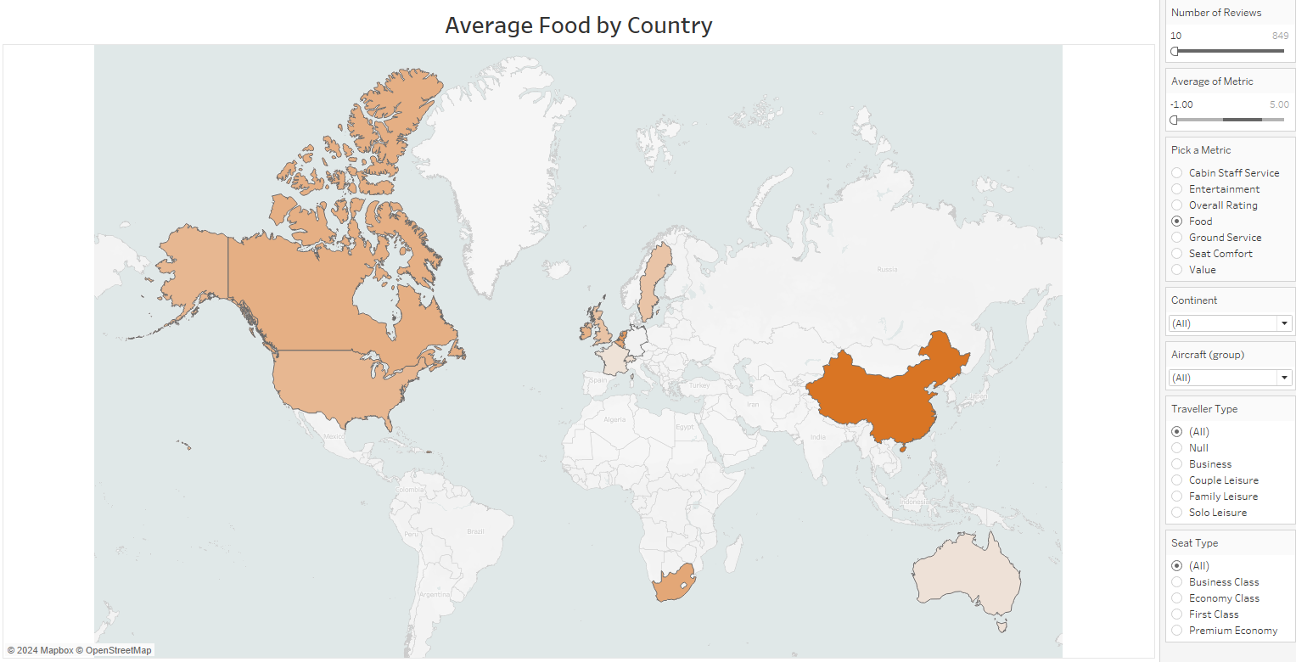

So, in conclusion, the main findings found were that the lack of reviews during Covid was the cause of drops in some metrics, Overall Rating has been declining since 2016, and Entertainment and Food are the biggest contributors to the decline, especially in the European market.

**Research:**

Thus far, we have discovered the largest issue revolves around low Entertainment and Food scores. Next, we need to identify what is specifically causing these low scores. To do this, I first turned to conducting my own research on what policies British Airways has in place and what has changed over the years.

The first article I found is by CNBC and talks about how in October of 2020, they “cut cash operating costs by 54% from original plans to 205 million euros per week during the July-September period.” This is likely due to Covid travel restrictions forcing British Airways to reduce the quality of some of its services in order to stay in business. It also further explains the drop in KPIs we saw in the July, 2020 to October, 2023 time period.

The next article I found, by Forbes, shows that in January of 2017 they were implementing a “new scheme to charge for food and drinks, including bottled water and sodas, to economy class passengers on domestic and European flights.” This seems to corroborate the low scoring for food by the customers.

The final article I found was directly from British Airways and showed that for in-flight entertainment, they offer wifi and a large selection of Paramount+ content to watch. This is odd, as it seems to contradict the low rating given by customers for this category. However, this discrepancy was well explained once I decided to delve into the specific contents of some of the low rated reviews:

1. “Paid £4.99 for 1 hours wifi, and dropped connection for the next 40 mins.”
2. “5 hours in a cramped single aisle aircraft, no inflight entertainment. In economy there is no free catering other than a bottle of water a pack of crisps and a minimal selection of food items for purchase.”
3. “The food is shocking and over priced. The planes are outdated.”
4. “Entertainment system didn’t work and… no solution. Food [was] bad, beef overcooked, mashed potatoes dry and salad disgusting.”
5. “Some A320s don’t even have the overhead screens, these are the new ones which do have in seat power though.In any event you will need to supply your own entertainment, and food/drink if you are in economy.”

The final review came from a TripAdvisor forum, not the dataset, and was made by a UK customer in 2019. However, I still decided to include it, as I felt that it summed up the other reviews’ main complaints fairly succinctly. The reviews left about food seem to be in line with what the Forbes article was stating, as the chief complaints were about how food had limited options, was low quality, and expensive.

However, it was the reviews about entertainment that were truly clarifying. They showed that, although British Airways offer wifi and movies, the wifi connection is inconsistent, leaving customers paying for a service they don’t even get to use. It also showed that in many of their older aircraft, like the A320, their screen systems are out of date or not even available, rendering the whole point of providing Paramount+ moot.

**Recommendations:**

Now that we have established the root cause of the complaints, we can move on to the final recommendations:

1. **Food -** I propose that they provide a form of 3-tiered access. For the free tier, provide a wide range of different cheap snacks and drinks options, so that everyone has the option of having at least something. Then offer a standard price tier where they get access to a smaller range of higher quality food that could more so be considered as genuine meals. By keeping the range of items smaller that would reduce waste, as this tier would likely include more perishable goods than the free tier. The final, most expensive tier would focus on a limited selection of gourmet products that cater more to the luxury fliers. Additionally, perhaps these tiers can be restricted based on travel time. For example, the middle and high tiers could only be available on flights lasting longer than 1.5 hours.
2. **Entertainment -** My proposal involves changing the internet provider to Starlink and updating the older planes to provide screen access to all passengers. I would change providers because, according to an article by CNN, traditional air to ground services only provide speeds of up to 5 mbps, compared to Starlink’s 200 mbps. I would also update the planes, considering oftentimes customers aren’t even able to take advantage of the freely provided streaming service, due to lacking a screen to watch anything on.

**Conclusion:**

To recap, over the course of this project we first performed Exploratory Data Analysis, building visualizations and a dashboard in Tableau that let us identify a few key trends. We then performed additional research, identifying the root causes behind these trends. To conclude, we were able to make a couple recommendations to British Airways, as we found that with just a few targeted changes, they will be able to reverse the trends.

Works Cited

<https://www.forbes.com/sites/douggollan/2017/01/18/did-british-airways-make-one-cut-too-many/>

<https://www.cnbc.com/2020/10/30/british-airways-owner-iag-slashes-costs-to-survive-covid-chaos-.html>

<https://www.britishairways.com/content/information/entertainment>

<https://www.tripadvisor.com/ShowTopic-g1-i10702-k12467475-BA_inflight_entertainment-Air_Travel.html>

<https://www.starlink.com/business/aviation>

<https://www.cnn.com/2022/09/03/tech/inflight-wifi-technology/index.html>